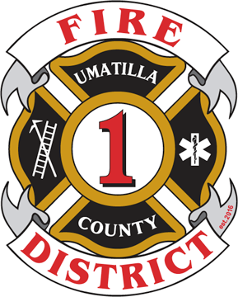
Umatilla County Fire District #1

320 S. 1st Street
Hermiston, OR 97838
541-567-8822 Bus | ucfd1.com
541-564-6463 Fax | fire.district@ucfd1.com

Dear Interested Community Member:

We are excited that you are interested in serving on the Umatilla County Fire District #1 Board of Directors. We hope that this information packet answers all your questions concerning the open position.

Within this packet you will find information about special districts, fire districts specifically, what it means to be a board member, and how to serve on our board.

Next Steps
- Review this packet
- Contact Chief Stanton at sstanton@ucfd1.com to submit an application by June 7, 2024 by 5 p.m.to be considered to fill the vacancy.

Thank you for your interest in serving on our board! If you have any questions, please don’t hesitate to contact Scott Stanton, Fire Chief, at sstanton@ucfd1.com and/or 541-567-8822.

Sincerely,

Ric Sherman
Umatilla County Fire District #1
Board President

