Umatilla County Fire District #1
  - MCI Plan implemented February 2013
Review Date: 2/2016
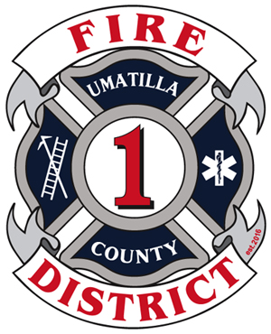

Contents
Objectives 1
Scope 2
Incident Command 2
Command Post Functions Include: 2
Staging Areas 3
Medical (EMS) Branch 3
Triage 3
Treatment 5
Transport 6
MCI Kit 6

Task Cards

Incident Commander Checklist 8
Medical (EMS) Branch Director Checklist 9
Triage Unit Leader Checklist 10
Treatment Unit Leader Checklist 11
Transport Unit Leader Checklist 12

Patient Transport Log 13

Resource Tables
Table 1 – Resource Contact List 14
Table 2 - Hospital Resource List 14
Table 3 - Air Ambulance 15
Table 4 - Fire & EMS agencies (Umatilla Co. and nearby) 15

Objectives
- To prevent as many deaths and disabling injuries as possible during a mass casualty incident (MCI).
- To provide a framework for triage, treatment, and transport for victims of a MCI.
- To ensure safe and efficient use of resources.
- To ensure the safety of all responding personnel.

Scope
Coordinate a response of many different types and kinds of resources to an incident in our local response area that would overwhelm the local health care and/or EMS systems.
The first unit on-scene will notify medical control and dispatch that this incident is a MCI. This plan falls under the NIMS framework and the organizational structure is expandable/collapsible as needed. Under this plan, training is required at least once a year. It is acceptable and expected that this plan be used on smaller incidents that are not truly overwhelming, such as multiple patient MVCs, or incidents with other complexities.
Task Card/Checklists are to be kept in the MCI kit. To use this plan follow individual checklists found in the MCI kit.

Incident Command
- The Incident Command System (ICS) will be established by the first arriving unit on-scene. Overall command of the situation will be assumed and a command post established. Overall incident operations are under the direction of the Incident Commander (IC). Face-to-face transfer of command is required when changing incident commanders.
- Deploy MCI kit
- Complete Incident Commander Checklist from MCI kit.
- Don “IC” vest
- Assign divisions/braches as not to exceed span of control. A medical branch or partial components of the medical branch should be a high priority during an MCI.
- Ensure the safety of responders, the scene, and bystanders.
- The Incident Commander will identify him/herself and give a brief report of the situation to dispatch. Initial radio report should consist of:
  - The name of incident and identity of the Incident Commander.
  - A brief size-up and declare a MCI.
  - Exact location of the Command Post.
  - Approach routes and staging areas.
- The IC shall consider initially requesting an MCI unit (various MCI trailers and Umatilla Heavy Rescue 12) to facilitate getting the unit rolling early
- Activate the Umatilla County EOC and/or UCFD1 Ops center.
- Assign LZ Coordinator
- Establish Decon or HazMat Branch when needed to decon patients

Command Post
1. A location from which all operations are directed.
2. Unified Command should be considered. (as needed, such as a crime scene)
3. Law enforcement supervisor, Public Information officer and Safety officer will co-locate at the command post.

EOC / UCFD1 Operations Center
The EOC for Umatilla County is activated through dispatch. UCFD1 operations center is located at UCFD1 Station 21 and is activated by contacting UCFD1 at 541-567-8822. Staffing the EOC/Ops Center will be instrumental in gathering resources and personnel. Staff will be able to call/text/page additional personnel, coordinate services, create shift rotations, and ensure other calls are handled. Attempts to staff station for additional calls should be made by any means that will be determined at the time of incident.

Staging Areas
Establish Staging and assign Staging Area Manager

Medical (EMS) Branch
Sometimes referred to EMS Branch, the Medical Branch Director is directly responsible for the following:
- Coordinate with other ICS Branches and IC
- Establish Medical Channel (as needed)
- The following positions:
  - Triage
  - Treatment
  - Transport
- Ordering resources through the IC or resource officer
- Establishing Ambulance Staging Area if different from main staging location
- Accountability of Medical Personnel

Triage
The Triage Unit Leader is responsible for ensuring initial and on-going triage during an MCI. In addition the Triage Unit Leader is required to complete the following:
- Obtain and complete the Triage Unit Leader Checklist
- Ensure all patients are tagged
- Coordinate movement of triaged patients to other areas (work with Treatment and Transport Units). Use assigned crews to move patients
- Coordinate and provide accountability for crews
- Relay triage information up the chain-of-command
Simple Triage and Rapid Treatment (START) is the most universal triage method in the United States. Jump Start for pediatric patients is also widely acceptable. Umatilla County Fire District #1 will use current START (Figure 1) and Jump START (Figure 2) guidelines for initial triage. Initially all ambulatory patients are green. Leave black tagged patients in place when possible. Remember the Mnemonic RPM (Respirations, Pulse, Mentation) 30-2-Can Do. Ongoing triage will continue throughout the incident, including the treatment areas, up to the point of transport.
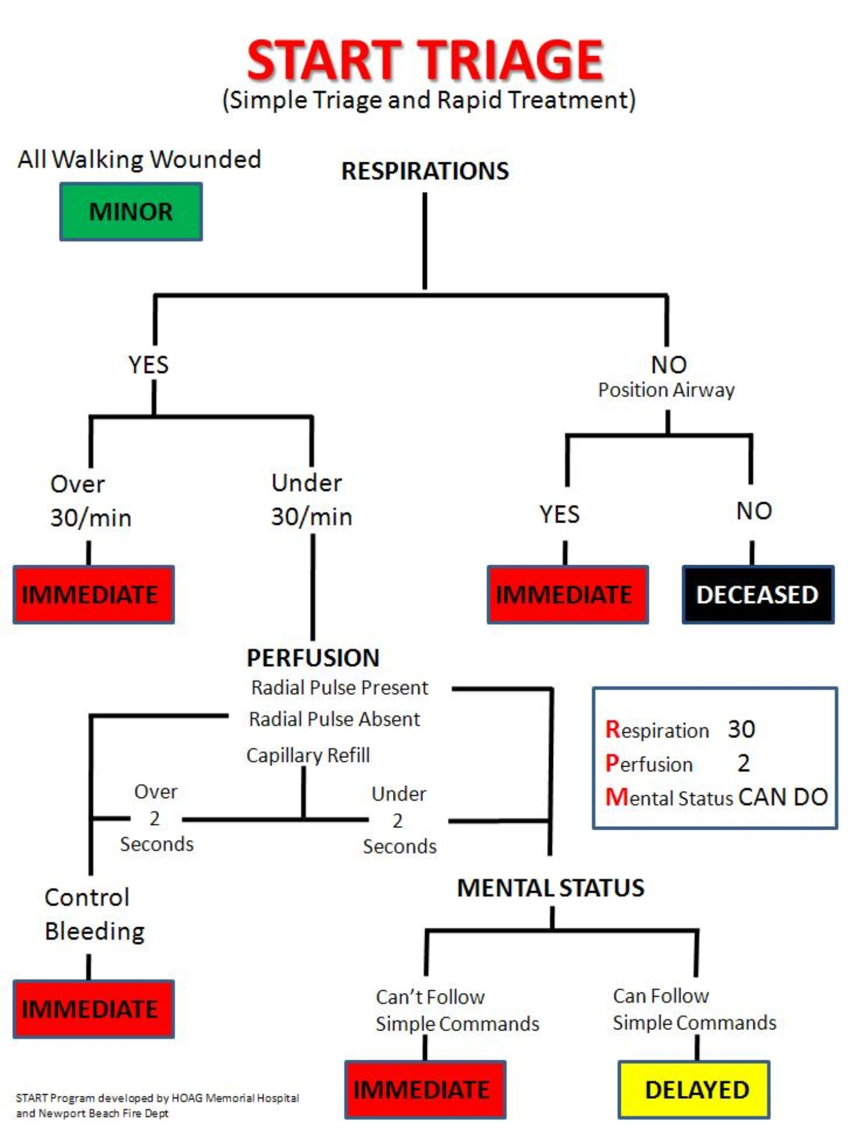
Figure 1
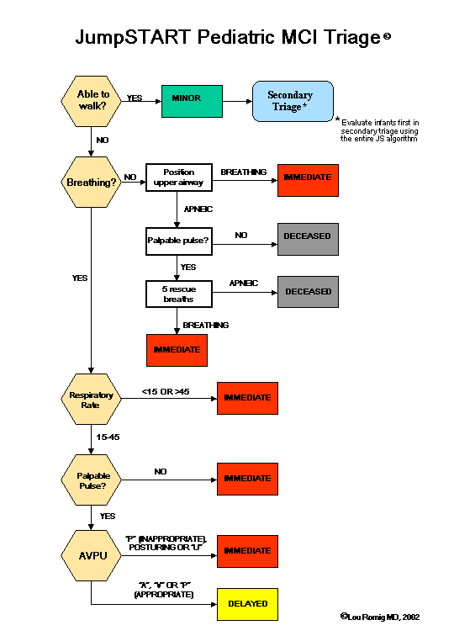
Figure 2

Treatment
The Treatment Unit Leader manages the treatment area of an MCI including set up and coordinating the treatment area. The location for the treatment area will be determined at the specific incident scene, but should provide for easy access and egress both from where the patients are found and the transport areas. The treatment area shall be separated into three different zones consisting of red, yellow, and green. The zones need to be identified with cones, tarps, or colored tape. Personnel can be assigned to work in separate zones as needed. Accountability is the responsibility of the Treatment Unit Leader. The Treatment Unit Leader is required to obtain and complete the Treatment Unit Leader Checklist, including the following:
- Designate & identify treatment area, including red, yellow, and green zones
- Provide access with room to expand
- Provide for environmental protection
- Identify multiple treatment areas with geographic names (North/South, street name)
- Order resources through Medical Branch Director
- Identify entry point
- Identify exit point or Loading zone
- Ensure all patients have a triage tag
- Coordinate patient movement to loading zone with Transportation
- Provide accountability for personnel

Transport
The transport Unit Leader is responsible for the coordination of transporting all patients to a medical facility. Transport should set up close to the treatment area and work closely with the Treatment Unit to determine the order of transporting patients from the scene. The Transport Unit is responsible for communicating with destination hospitals. Individual medic units shall not contact the emergency department nor give a patient care report during an MCI unless their patient’s conditions deteriorate significantly during transport.
- Establish Loading Zone
- Establish access/egress with Staging
- Request resources from Medical
- Supervise patient movement to loading zone (work with Treatment)
- Monitor radio traffic (to estimate number of patients)
- Establish communications with GSMC
- Confirm MCI with GSMC
- Provide total number of estimated patients to GSMC
- Coordinate destinations
- Provide report to destination hospital for each unit leaving the scene:
  - Unit #
  - Triage tag #’s
  - Color/Categories
  - Age/gender
  - Brief* injury/treatment update
- Confirm hospital destination with GSMC and record
- Maintain Patient Transport Log

MCI Kit
The MCI kit will be carried on BC21 and shall be removed and placed on another front line vehicle when BC21 is out of service or out of the area. Contents of kit will include:
- IC vest and checklist
- Medical Officer vest and checklist
- Triage vest and checklist
- Treatment vest and checklist
- Transport vest and checklist
- Red, yellow, and green tarps
- Red, yellow, and green tape
- Red, yellow, and green cones
- Additional triage tags
- Erasable markers/Grease pens
- Pens
- Clipboards X 6
- Multiple Patient Transport Log
- START or Jump Start laminated cards ?
- Resource list (or keep in Ops/EOC?) maybe both or all three?

Incident Commander Checklist
- Assume command on radio and face-to-face with previous IC (if applicable)
- Deploy MCI kit
- Don IC vest
- Identify the command post and establish unified command
- Identify Staging
- Assign staff positions and branches as needed (span of control)

Consider activating EOC/Ops center for resource ordering (Resource Tables
- Table 1 – Resource Contact List)

Medical (EMS) Branch Director Checklist
- Coordinate with other ICS Branches and IC
- Establish Medical Channel
- Establish the following positions:
  - Triage: _______________
  - Treatment: _________________
  - Transport: _________________
- Order resources through IC
- Establish Ambulance Staging Area if different from main staging location
- Accountability of Medical Personnel(?)

Triage Unit Leader Checklist
- Ensure all patients are tagged
- Coordinate movement of triaged patients to other areas (work with Treatment and Transport Units)
  - Assign teams
- Coordinate and provide accountability for crews assigned to you
- Relay triage information up the chain-of-command
- Patient’s may have to be moved before triage
- Ongoing Triage
Red* Immediate life threat. (rapid transport)
Yellow* Delayed (1-3 hours)
Green* Ambulatory (3 plus hours)
Black* Dead (Move only if needed to reach other live patients, out of view)

Treatment Unit Leader Checklist
- Designate & identify treatment areas, including red, yellow, and green zones
- Provide access with room to expand
- Provide for environmental protection
- Identify multiple treatment areas with geographic names
(North/South, street name)
- Order resources through Medical Branch Director
- Identify entry point
- Identify exit point or Loading zone
- Ensure all patients have a triage tag
- Coordinate patient movement to loading zone with Transportation
- Provide accountability for crews assigned to you

Transport Unit Leader Checklist
- Establish Loading Zone
- Establish access/egress with Staging
- Request resources from Medical
- Supervise patient movement to loading zone (work with Treatment)
- Monitor radio traffic (to estimate number of patients)
- Establish communications with GSMC
  - HEAR
  - Phone (541-667-3533)
  - 450 mHrtz
- Confirm MCI with GSMC
- Provide total number of estimated patients to GSMC
- Coordinate destinations
- Provide report to destination hospital for each unit leaving the scene:
  - Unit #
  - Triage tag #’s
  - Color/Categories
  - Age/gender
  - Brief* injury/treatment update
    - Confirm hospital destination with GSMC and record

- Maintain Transport Log

Tag # | Unit # | Color | Injury | Destination | Report given
 |  |  |  |  | ☐
 |  |  |  |  | ☐
 |  |  |  |  | ☐
 |  |  |  |  | ☐
 |  |  |  |  | ☐
 |  |  |  |  | ☐
 |  |  |  |  | ☐
 |  |  |  |  | ☐
 |  |  |  |  | ☐
 |  |  |  |  | ☐
 |  |  |  |  | ☐
 |  |  |  |  | ☐
 |  |  |  |  | ☐
 |  |  |  |  | ☐
 |  |  |  |  | ☐
 |  |  |  |  | ☐

Patient Transport Log Page ________

Resource Tables

Table 1 – Resource Contact List
Resource | Contact | Emergenct Phone | potential uses
Mobile Command Post & Rehab Unit | Morrow Co. Dispatch | 541-676-5317 | Rehab, air, ICP
Umatilla County Search & Rescue | Umatilla Co. Dispatch | 541-966-3651 | ATV, Snowmobile, Command bus
Technical Rescue Team (Tri-Cities) | Benton Co. Dispatch | 509-628-2616 | Confined Space, Trench, High/Low Angle Rescue
Morrow Co. Search & Rescue | Morrow Co. Dispatch | 541-676-5317 | ATV ambulance, ATV
Red Cross |  | 541-276-1211  888-680-1455 | Shelter, Rehab
ODOT |  | 800-977-6368 | Equipment, Traffic
Umatilla Co. Emergency Management | Jack Remillard/duty phone | 541-310-0583 | EOC
Washington Demil Clinic |  | 541-564-7211 | Ambulance
UEC | On-call tech | 888-465-5071 541-561-5368 | Equipment, boom truck, Snow Cat
Wood Pecker Trucks | John Rehberge | 541-969-7984  541-276-5515 | Heavy duty wrecker, mobile service
Heller & Sons | Mike/Jim Heller | 541-571-1240  541-571-1241  541-561-4992 | Fueling
Benton Co. Dive Rescue | Benton Co. Dispatch | 509-628-2616
Eagle Freightliner |  | 541-567-5677 | Heavy duty wrecker
NW Metal Fab |  |  | Crane
OERS |  | 800-452-0311 | USAR, HAZMAT, All hazard
Mid-Columbia Bus Company | John Griffith | 541-571-5075 541-571-5073
Mobile Communications Unit | Shawn Halsey | 541-969-7592 | Mobile radio tower, hotspot
National Weather Service |  | 541-276-7832

Table 2 - Hospital Resource List
Good Shepherd | Hermiston | 541-667-3533
St. Anthony | Pendleton | 541-276-5121
Pioneer Memorial | Heppner | 541-676-9133
Kennewick General | Kennewick | 509-586-5887
Kadlec | Richland | 509-943-5700
Our Lady of Lourdes | Pasco | 509-546-2207
St. Mary | Walla Walla | 509-525-2500
Walla Walla General | Walla Walla | 509-527-8264

Table 3 - Air Ambulance
Life Flight | 800-232-0911 or 208-367-3880 | Multiple rotor and fixed wing
NW Med Star | 509-532-7990 or 800-422-2440 | Multiple rotor and fixed wing

Table 4 - Fire & EMS agencies (Umatilla Co. and nearby)
Agency | Phone | Number of transporting units
Umatilla County Fire District #1 | 541-567-8822 | 5 ambulances
Pendleton Fire | 541-276-1442 | 4 ambulances
Tribal Fire | 541-276-2126 | 2 ambulances
Umatilla Fire | 541-922-3718 | 2 ambulances
Medic 400 | 541-566-3813 | 2 ambulances
Morrow Co. EMS | 541-481-2202, 541-676-2922 | 2 Heppner, 2 Boardman, 1 Irrigon
Echo Fire | 541-376-8118 (Chief)
Pilot Rock Fire | 541-379-1295 (Chief)
East Umatilla Co. Fire
Heppner Fire
Benton Co. Fire District 6 | 509-875-2029 | 2 ambulances
Boardman Fire | 541-481-3473
Ione Fire
Lexington Fire
Irrigon Fire | 541-922-3133
Milton Freewater RFPD | 541-938-8266 | 2 ambulances
Milton Freewater City | 541-301-4725 (Chief)

Assembly areas | Contact | Phone
Pendleton Convention Center |  | 541-276-6569
Hermiston Community Center | Debbie Pedro | 541-571-3155, 541-567-6151
Hermiston Armory | Dan Hinkley, Dennis Corson | 541-561-2745, 541-910-6027
Umatilla County Fair | Peggy, Fair Manager | 541-379-8321 541-561-5326
Hermiston School Dist. | Mike Kay | 541-667-6019, 541-601-1545
Pendleton School Dist.

Logistics
Fire Corp – Hermiston | Robin Bozeman | 541-720-0027
Fire Corp -Boardman | Robin Bozeman | 541-720-0027
Jimmy Jons Portable Toilets | Jim | 541-571-2739, 541-571-3567
Doug’s Septic Service |  | 541-938-7405,541-276-9202,541-564-6612,541-922-3684,541-910-7322

PIOs | Phone | Agency
Pat Hart | 541-571-3062 | HFES
Mike Roxbury | 541-314-8855 | UFD
Jodi Florence | 541-429-3566, 541-966-3607 | UCSO
Casey White-Zollman | 541-969-4787, 541-966-3115 | IMESD
Joani Bosworth | 541-966-3115, 541-276-8247 | National Forest Service

State & Federal Agencies
FBI
ATF
Coast Guard
FEMA | 425-487-4610
National Guard
FAA
EPA | 541-962-7218
Army Corps of Engineers
National Weather | 541-276-7832
NTSB
OERS | 800-452-0311
OSFM HazMat Duty Officer | 503-589-2763

